import
spacy
import
pandas
as
pd
import
matplotlib.pyplot
as
plt
import
seaborn
as
sns
from
spacy.matcher
import
Matcher
df = pd.read_csv
(
"
/content/arxiv_data
5.csv"
)
titles
93
Inter Extreme Points Geodesics for Weakly Supe...
103
Semantics-aware Multi-modal Domain Translation...
124
RLCorrector: Reinforced Proofreading for Conne...
226
PointFlow: Flowing Semantics Through Points fo...
317
Color Image Segmentation Metrics
cs_df = df
[
df
[
'titles'
]
.
str
.contains
(
"cs"
, na=
False
)
]
cs_df
[
[
'titles'
]
]
.head
(
)
nlp = spacy.load
(
"en_core_web_sm"
)
docs =
list
(
nlp.pipe
(
cs_df
[
'titles'
]
.astype
(
str
)
)
)
noun_phrases =
[
]
for
doc
in
docs:
noun_phrases.extend
(
[
chunk.text
for
chunk
in
doc.noun_chunks
np_df = pd.DataFrame
(
noun_phrases, columns=
[
'phrase'
]
)
top_np = np_df
[
'phrase'
]
.value_counts
(
)
.head
(
15
)
plt.figure
(
figsize=
(
10
,
6
)
)
sns
barplot
(
top
np
al
es
top
np
inde
color
"bl
e"
)
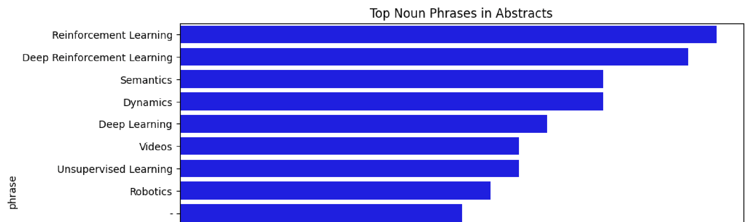
sns.barplot
(
x=top_np.values, y=top_np.index, color=
blue
)
plt.title
(
"Top Noun Phrases in Abstracts"
)
plt.xlabel
(
"Frequency"
)
plt.show
(
)
entities = []
for
doc
in
docs:

for
ent
in
doc.ents:
entities.append((ent.text, ent.label_))
ent_df = pd.DataFrame(entities, columns=[
'entity'
,
'label'
])
top_entities = ent_df[
'label'
]
.value_counts
()
plt.figure(figsize=(
8
,
6
))
sns.barplot(x=top_entities.values, y=top_entities.
index, color=
"green"
)
plt.title(
"Entity Frequency Distribution"
)
plt.xlabel(
"Count"
)
plt.show()
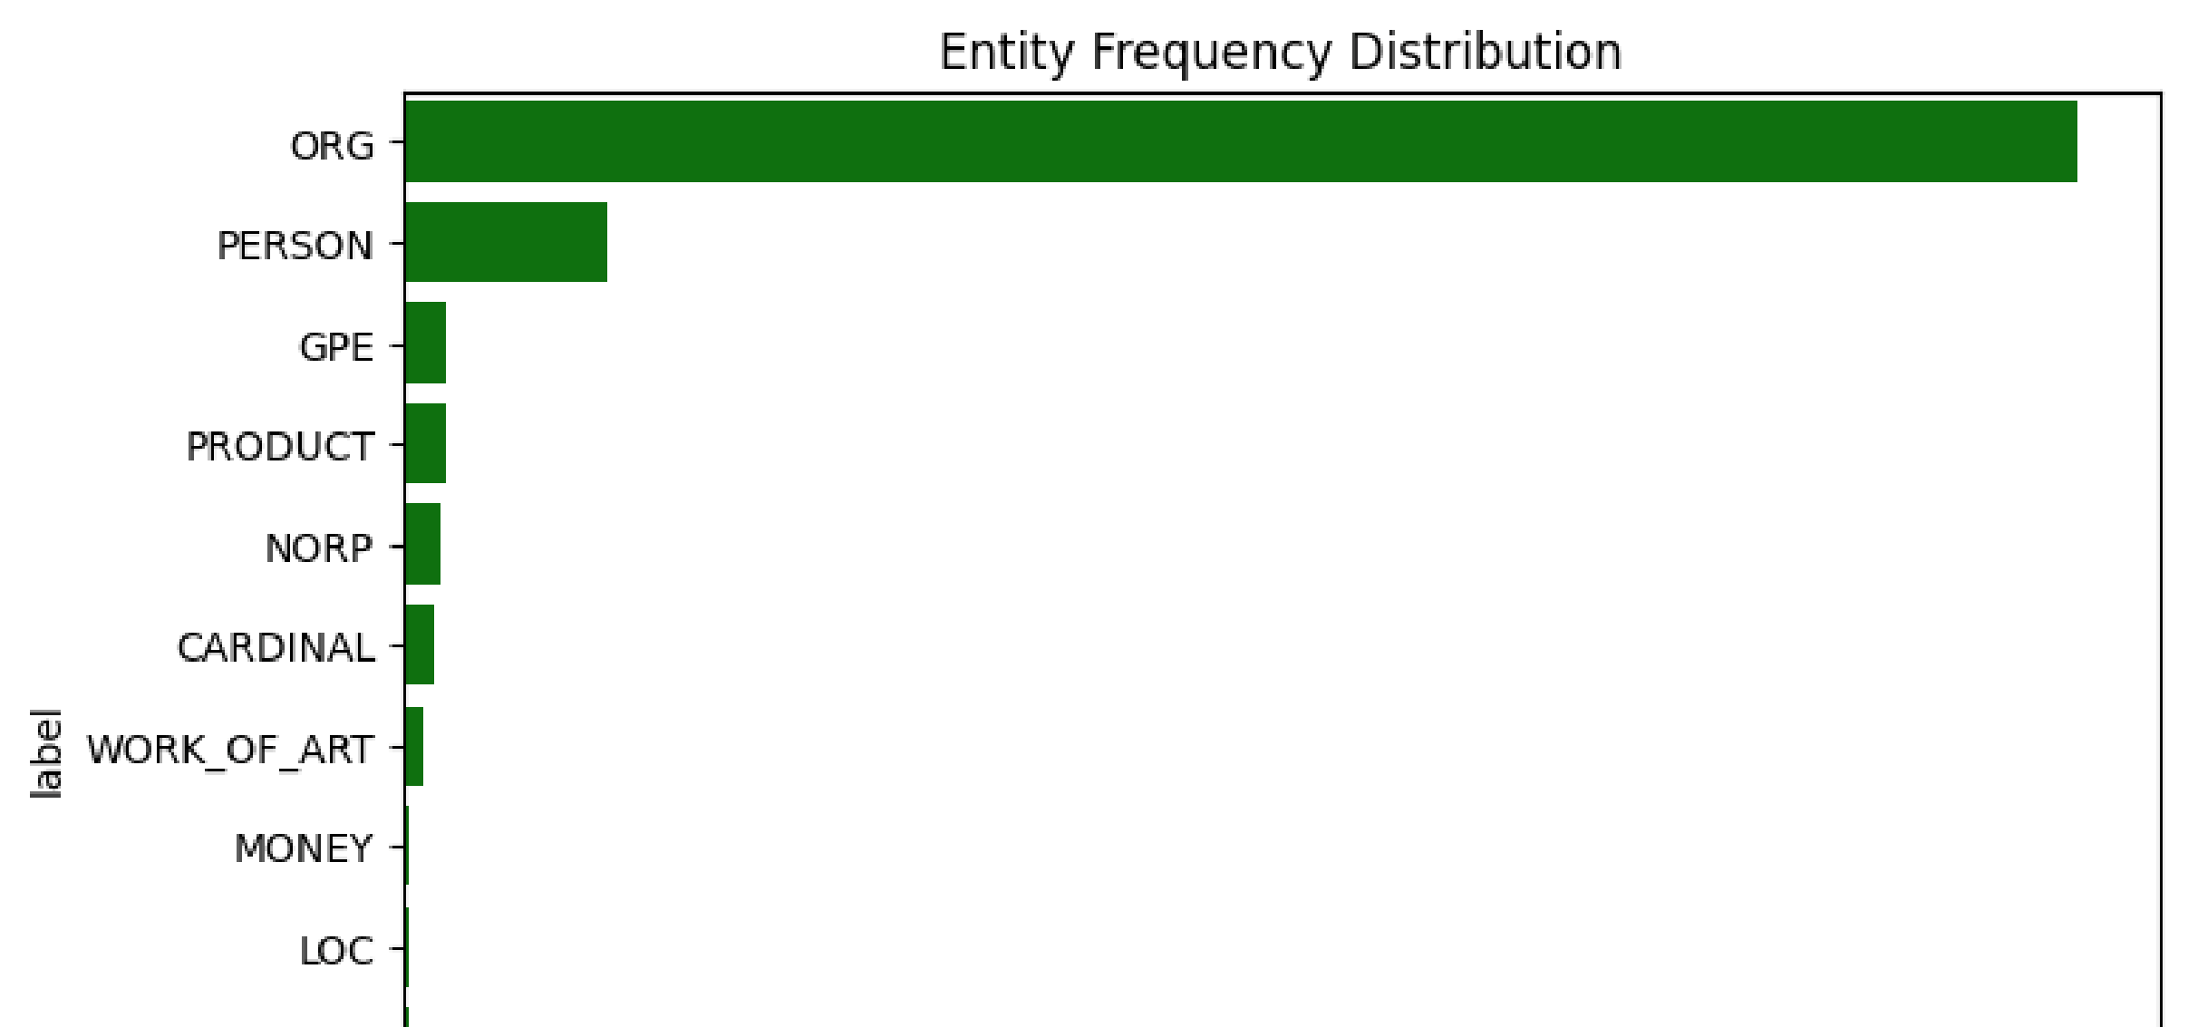
matcher = Matcher(nlp.vocab)
pattern1 = [{
"LOWER"
:

"neural"
}
,
{
"LOWER"
:

"network"
}]
pattern2 = [{
"LOWER"
:

"support"
}
,
{
"LOWER"
:

"vector"
}
,
{
"LOWER"
:

"machine"
}]
matcher.add(
"TECH_TERMS"
, [pattern1, pattern2])
matches = []
for
doc
in
docs:

for
match_id, start, end
in
matcher(doc):
span = doc[start:end]
matches.append(span.text)
pd.Series(matches).value_counts().head(
10
)
count
Neural Network
17
neural network
8
dtype:
int64
essay_text =
"Artificial intelligence is transforming research
i
doc = nlp
(
essay_text
)
print
(
"Tokens:"
,
[
token.text
for
token
in
doc
]
)
print
(
"Noun Phrases:"
,
[
chunk.text
for
chunk
in
doc.noun_chunks
]
print
(
"Entities:"
,
[
(
ent.text, ent.label_
)

for
ent
in
doc.ents
]
)
Tokens: ['Artificial', 'intelligence', 'is', 'transforming', 'research', 'in', 'computer', 'science', 'and', 'physics',
Noun Phrases: ['Artificial intelligence', 'research', 'computer science', 'physics']
Entities: []

